**Practical No. 7 - Joomla Installation**

Step 1 - visit <https://downloads.joomla.org> & download Joomla.

Step 2 - Extract Joomla zip file in Xampp > Htdocs Folder

Step 3 - visit Xampp-PhpMyAdmin through browser and create new database for Joomla.

Step 4 - Access Joomla Installation file using Browser through LocalHost.

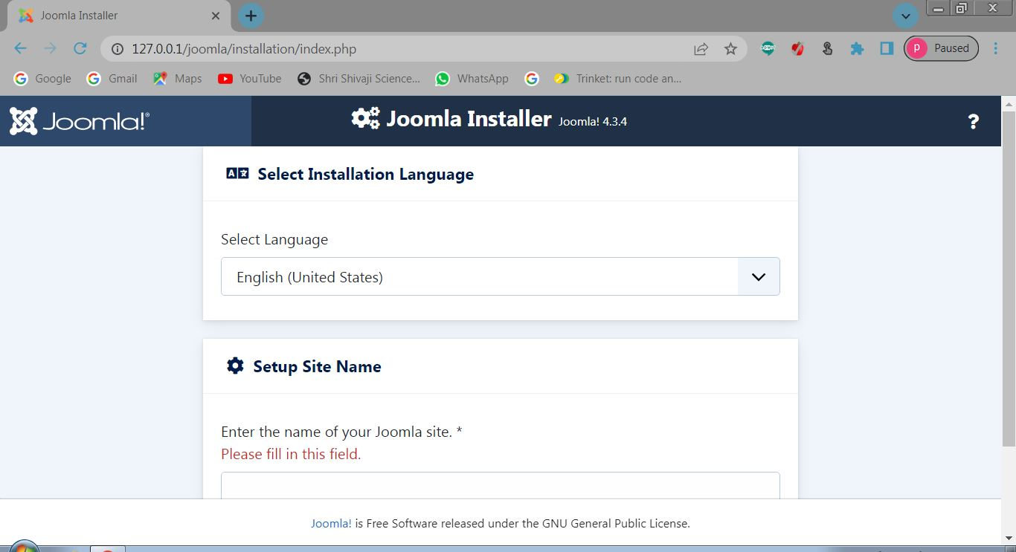

Step 5 - Set User Access data

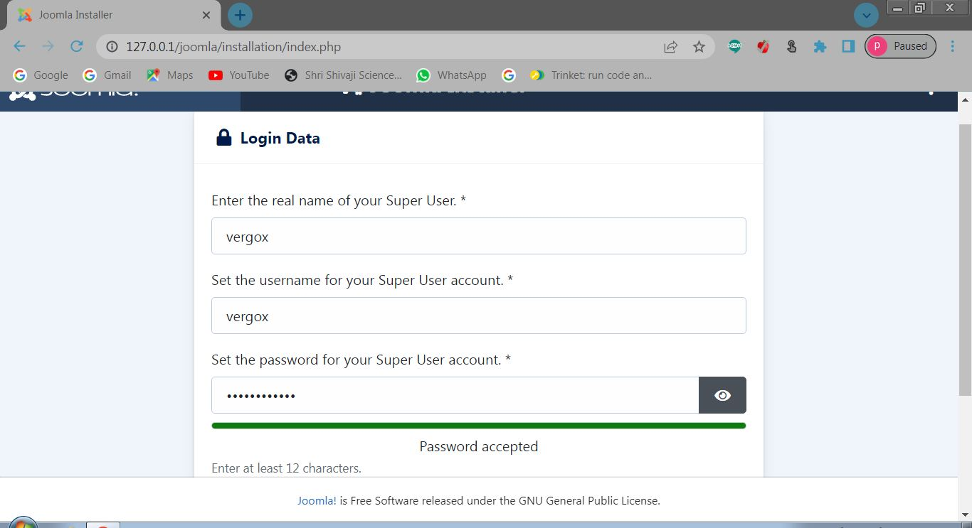

Step 6 - Enter Database details for Connection.

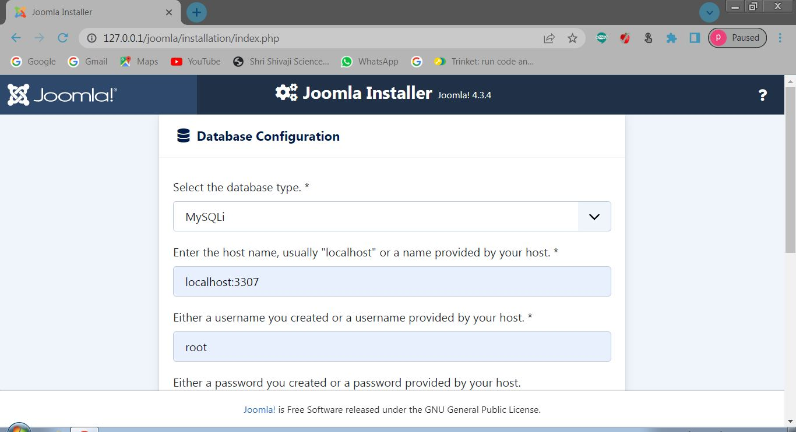

Step 7 - Site Installation Successful.

